Part 1:
Question 1. Main Entities & Key Attributes
Customer
- customer_id (PK)
- name
- email
- phone
- address
Flower
- flower_id (PK)
- name
- type (fresh/artificial/seasonal)
- color
- season
- price
- care_instructions
Category
- category_id (PK)
- name
Arrangement
- arrangement_id (PK)
- name
- complexity (simple/wedding/…)
- base_price
Order
- order_id (PK)
- order_date
- status
- customer_id (FK)
- delivery_option
OrderItem
- order_item_id (PK)
- order_id (FK)
- arrangement_id (FK)
- quantity
- price
Payment
- payment_id (PK)
- order_id (FK)
- amount
- payment_method
- status
Inventory
- flower_id (PK, FK)
- stock_quantity
Question 2: Conceptual ERD
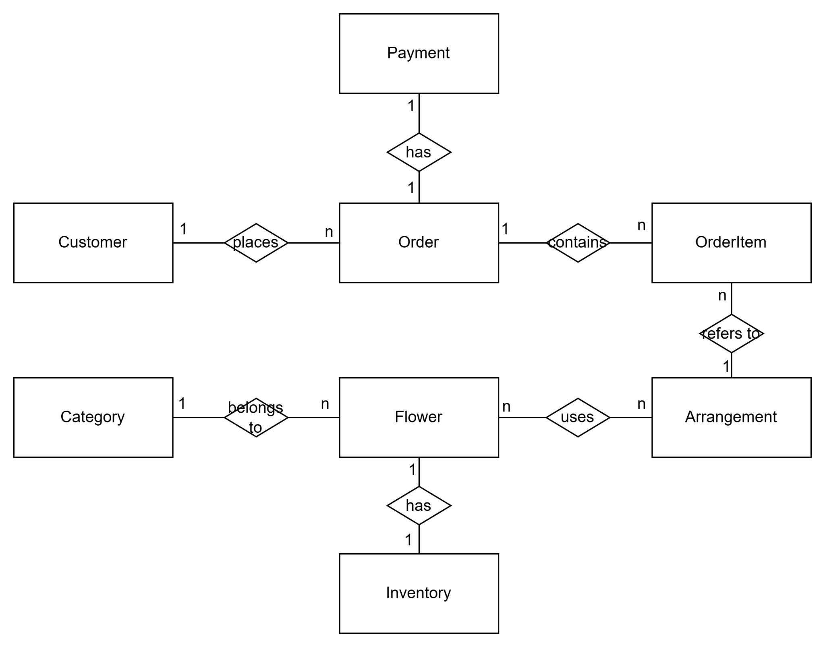
Question 3:
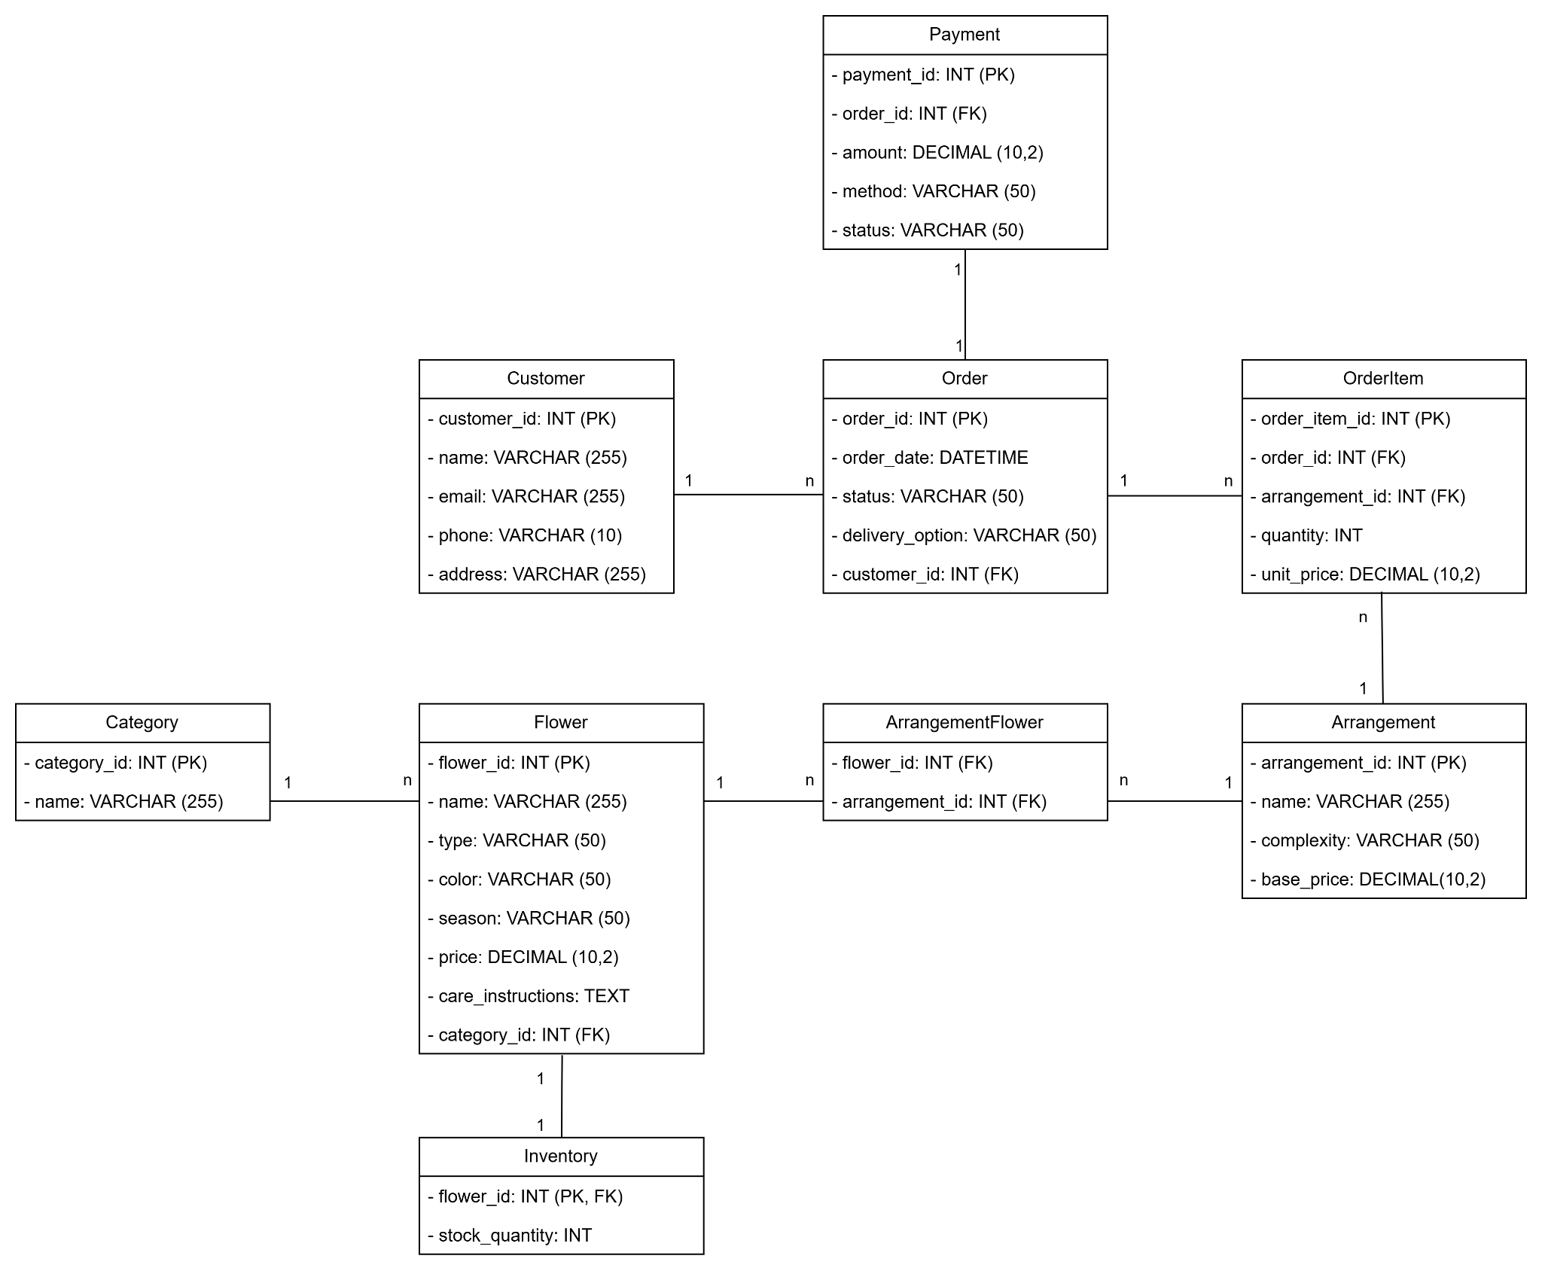
Question 4:
Main states of the Order entity:
- Pending – Order has been placed by the customer but not yet processed.
- Processing – Order is being prepared (arrangement design, flower preparation).
- Ready for Delivery – Order has been prepared and is ready to be delivered.
- Out for Delivery – Order is on the way to the customer.
- Delivered – Order has been successfully delivered to the customer.
- Cancelled – Order has been cancelled by the customer or staff before delivery.
- Failed Delivery – Delivery attempt failed (customer not available, wrong address, etc.)
State diagram for Order
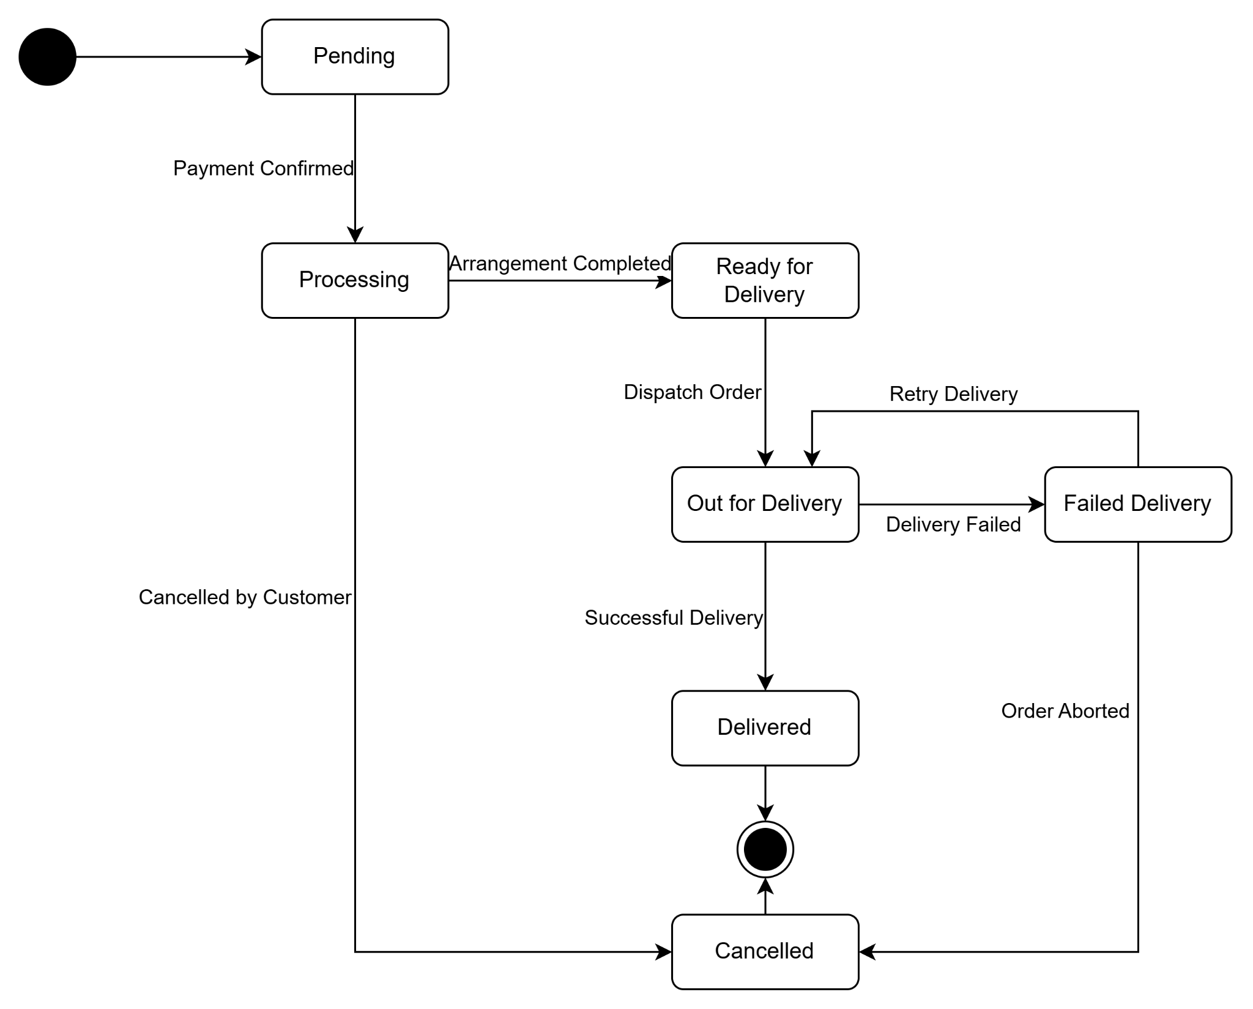

Part 2.
Question 5.
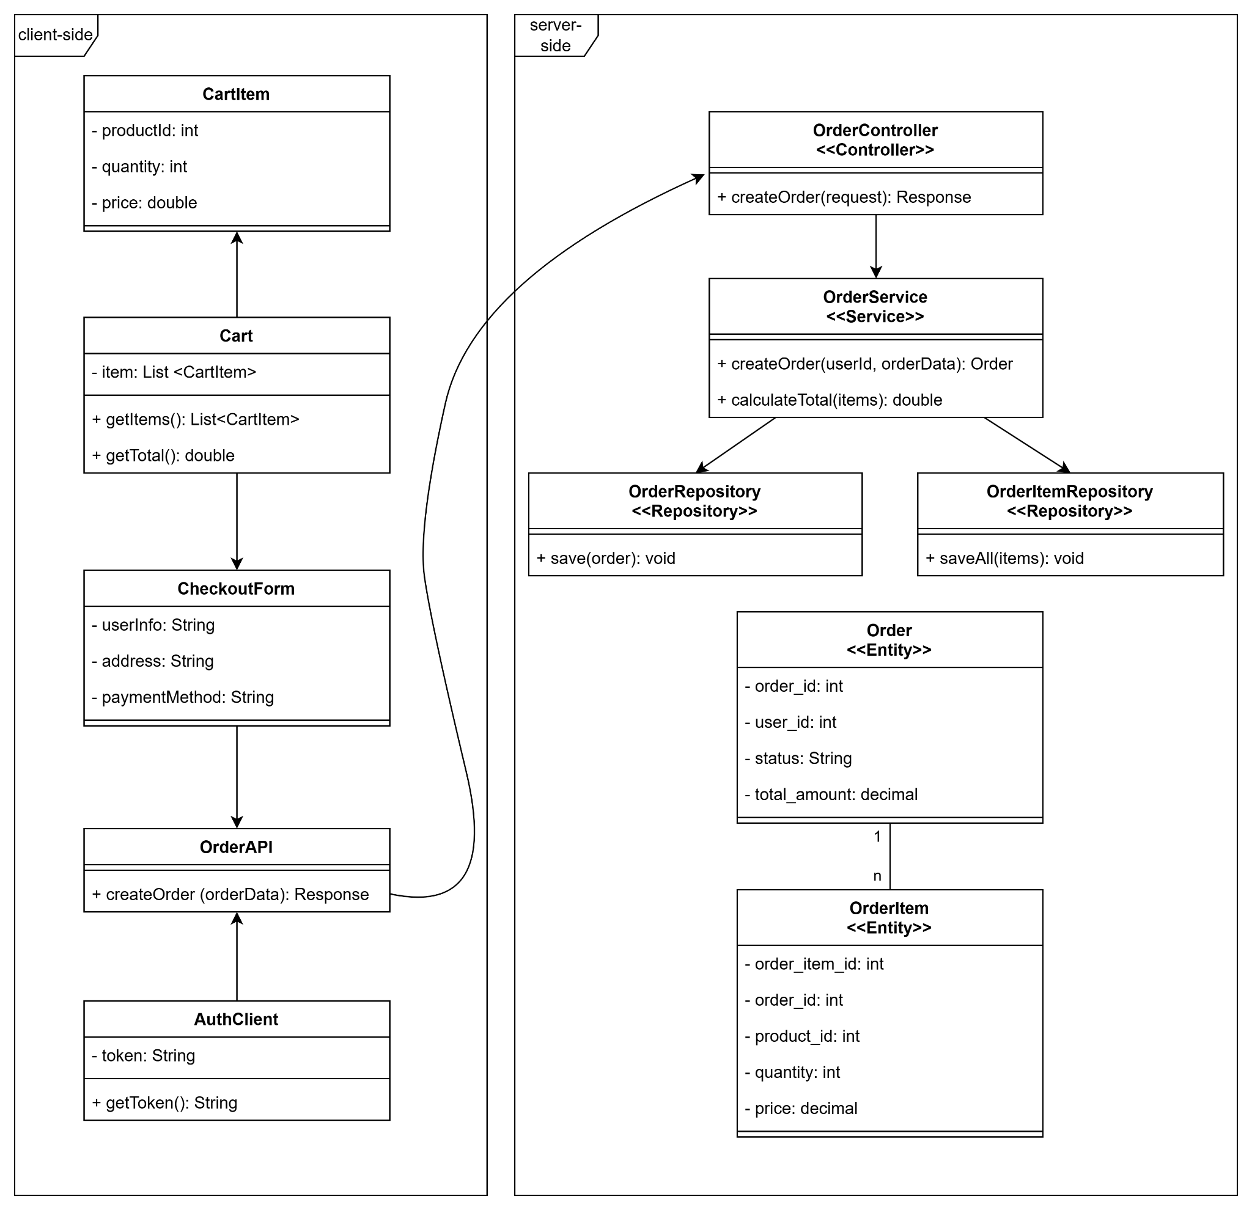
Question 6.

Part 3.
Question 1
Pattern Name: Strategy Pattern
Pattern Family: Behavioral Pattern
Question 2
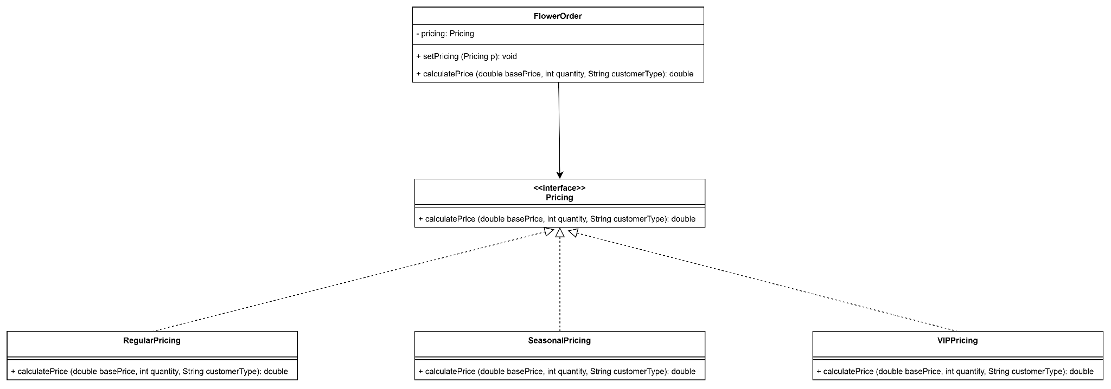
Question 3
A practical situation is supporting multiple payment methods in an e-commerce application. For example, users may choose to pay using credit cards, PayPal, or digital wallets. Each payment method can be implemented as a different strategy.

